Application Testing using

CukeTest

1. Testing inbuilt calculator application in windows 10

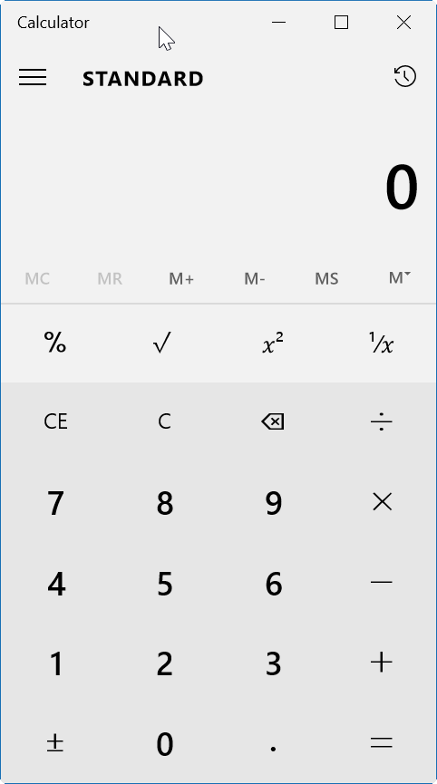

1. Opening CukeTest and creating a new project, with Windows template:

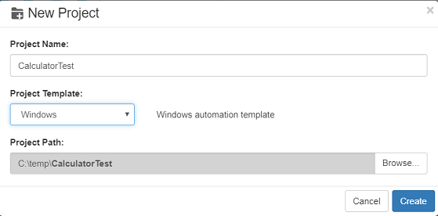

1. Creating object model

In this project we have created "model1.tmodel" file in the project tree to open Model Manager, which is a component of CukeTest. The object model file defines the test objects that maps to the controls on application under test, and the file has extension “. tmodel”. When automation testing runs, script uses the properties defined in the model file to locate the controls.

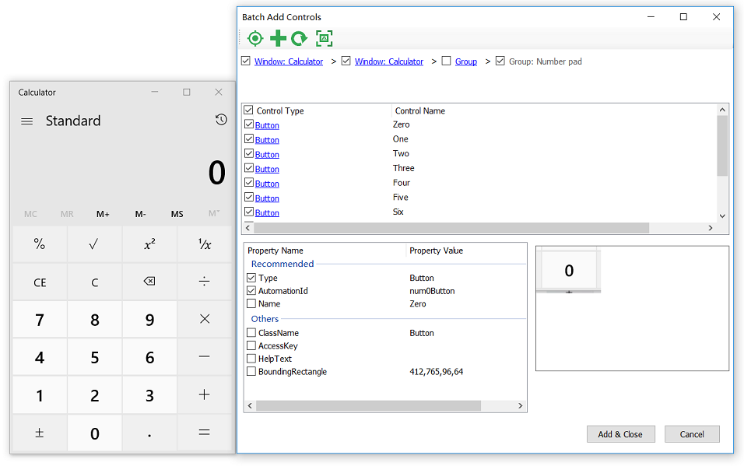

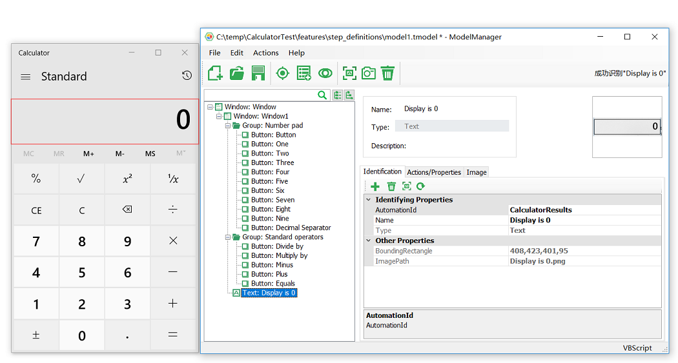

1. To ensure the object model you have created is working

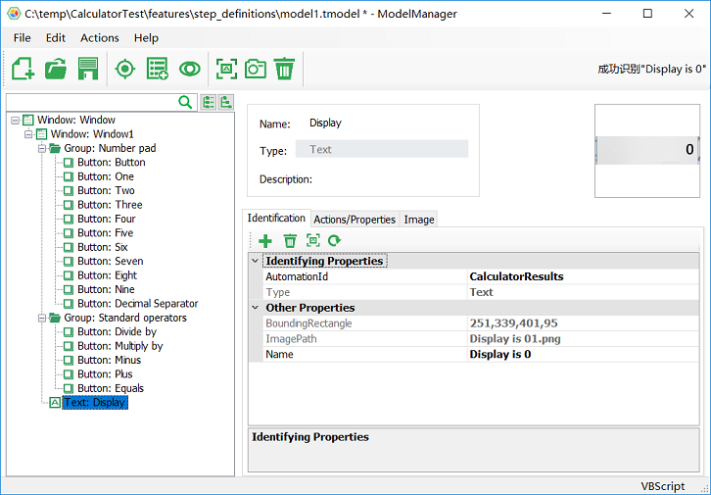

1. Now implementing automation code for the step definition function stubs

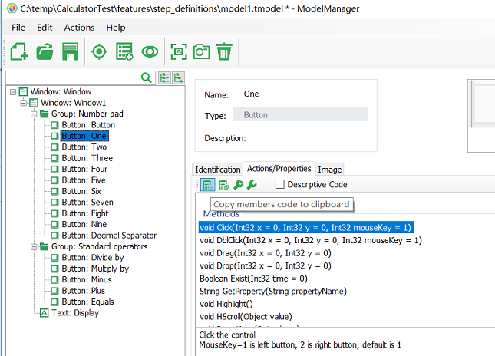

1. Making the test automation data driven

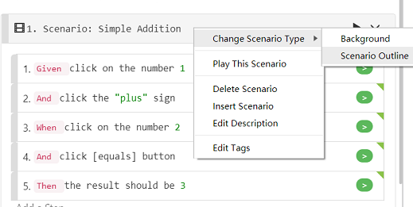

1. Adding data to Example table

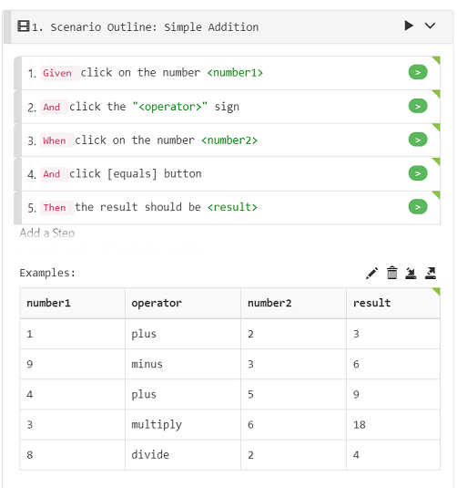

1. Test report

Click on the “Run Project” button on CukeTest to run the whole project. After running, CukeTest automatically shows you an html test report.

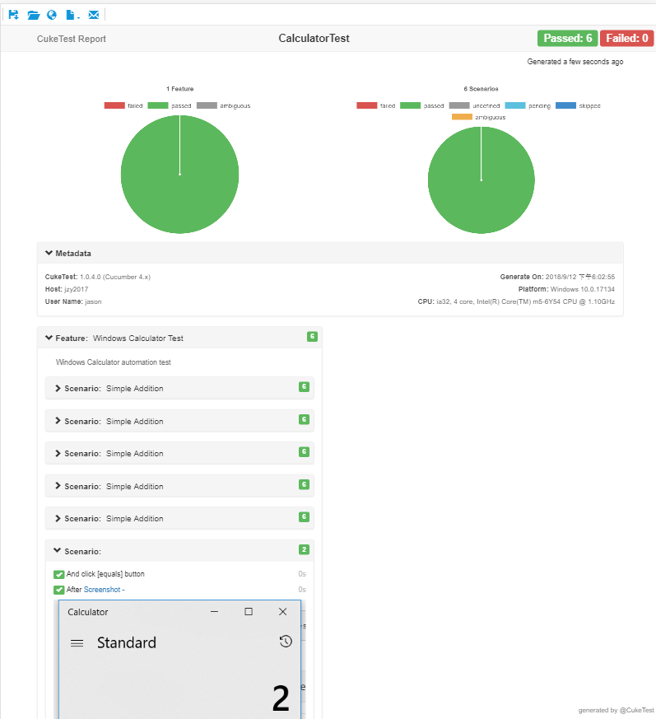

# Tools Used

# Cuke Test



Created by

* B.Vignesh
* 192IT254
* Information Technology
* I year II semester(Even)

--------------------------------------------------------------------------------------------------------------------------------------